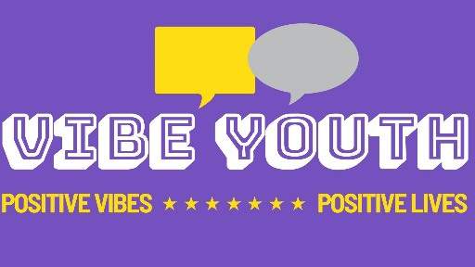
VIBE KIDS MEDIA CONSENT FORM
Your child has been selected to take part in the VIBE KIDS PROJECT.
This project was created to help support children feel more confident about the important transition from Primary school to comprehensive school. The project will take place in school within the usual school day.
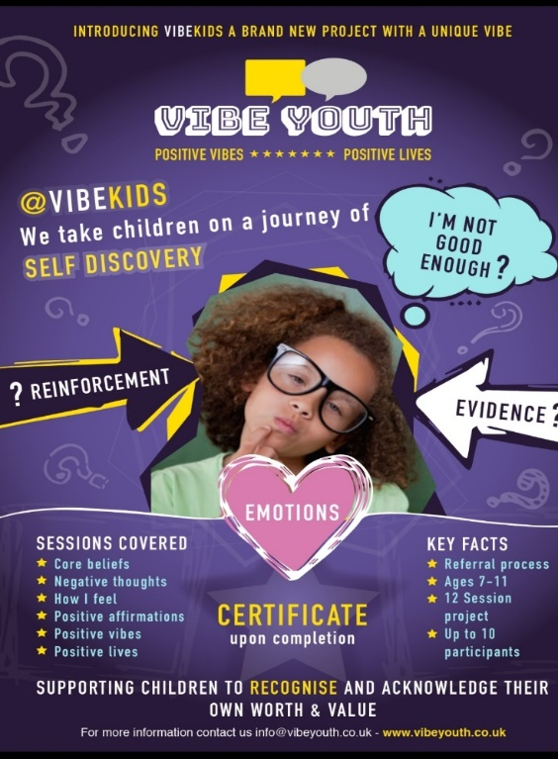

Declaration of consent – parent / carer of child under 16
Please tick each box to give consent, then sign this form. Please leave blank if consent is not given, then sign this form.
 | I give permission for my child’s photograph to be used within other printed publications.
 | I give permission for my child’s photograph to be used on the VIBES website.
 | I give permission for my child’s photograph to be used on VIBES social media pages.
 | I give permission for video of my child to be used on VIBES website.
 | I give permission for video of my child to be used on VIBES social media pages.
Signature |  |  | Date
Print name
Relationship

