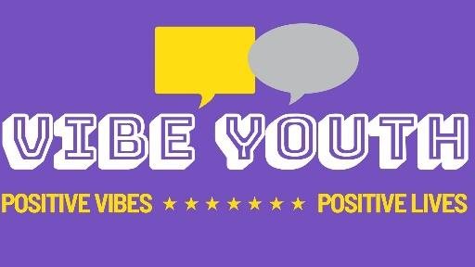
VIBE YOUTH MEDIA CONSENT FORM

Declaration of consent – Under 16
Please tick each box to give consent, then sign this form. Please leave blank if consent is not given, then sign this form.
◻ | I give permission for my photograph to be used within other printed publications.
◻ | I give permission for my photograph to be used on the VIBES website.
◻ | I give permission for my photograph to be used on VIBES social media pages.
◻ | I give permission for a video of myself to be used on VIBES website.
◻ | I give permission for videos of myself to be used on VIBES social media pages.
Signature |  | 🗶 | Date
Print name
Relationship

