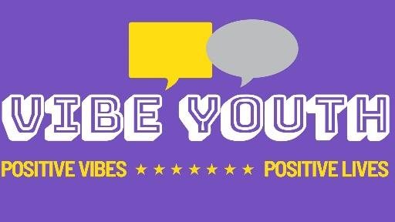
YOUR VIBE PROJECT MEDIA CONSENT FORM
The Your Vibe Project is a core Vibe Youth service created to promote and increase self-esteem, self-confidence, and self–belief by delivering a range of topics that are educationally and therapeutically based.
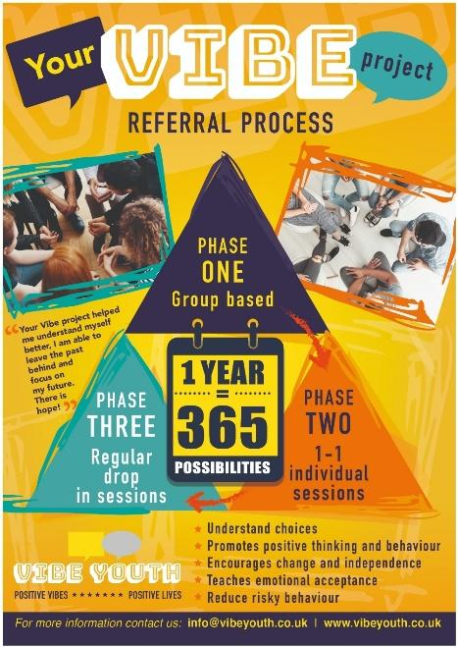

Declaration of consent – parent / carer of child under 16
Please tick each box to give consent, then sign this form. Please leave blank if consent is not given, then sign this form.
◻ | I give permission for my child’s photograph to be used within other printed publications.
◻ | I give permission for my child’s photograph to be used on the VIBES website.
◻ | I give permission for my child’s photograph to be used on VIBES social media pages.
◻ | I give permission for video of my child to be used on VIBES website.
◻ | I give permission for video of my child to be used on VIBES social media pages.
Signature |  | 🗶 | Date
Print name
Relationship

